Name: Varia Neel Jitesh
Enrollment No: 250447003019

Network Security And Forensics
Lab Session – 4
You are required to design and prepare your own website and make it publicly
available on the internet. To achieve this, complete the following:
1. Purchase a Domain Name from any registrar (e.g., GoDaddy, Namecheap, Google Domains).

A custom domain codingwell.live was successfully purchased using a domain registrar (GoDaddy).

Steps Performed:
- Logged into the domain registrar account
- Searched for the domain codingwell.live
- Completed the purchase process
- Accessed domain management dashboard

Outcome:
The domain was successfully registered and ready for DNS configuration.
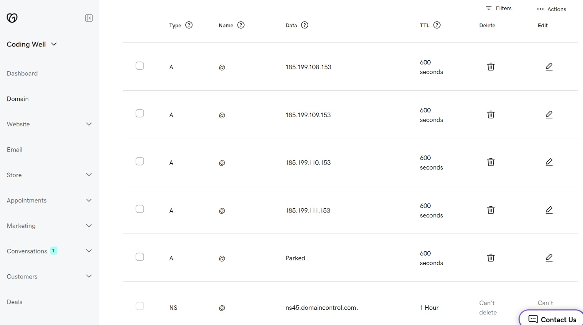
Domain DNS panel showing records and nameservers configured
2. Design and develop a simple website (using HTML, CSS, JavaScript, or a framework of your choice).

A complete website named “Coding Well” was designed and developed.
Technologies Used:
- HTML
- CSS
- JavaScript

Website Features:
- Navigation bar (Home, Services, Courses, Blog, etc.)
- Hero section with call-to-action
- Search functionality
- Responsive UI

Outcome:
The website was successfully developed and tested locally before deployment.
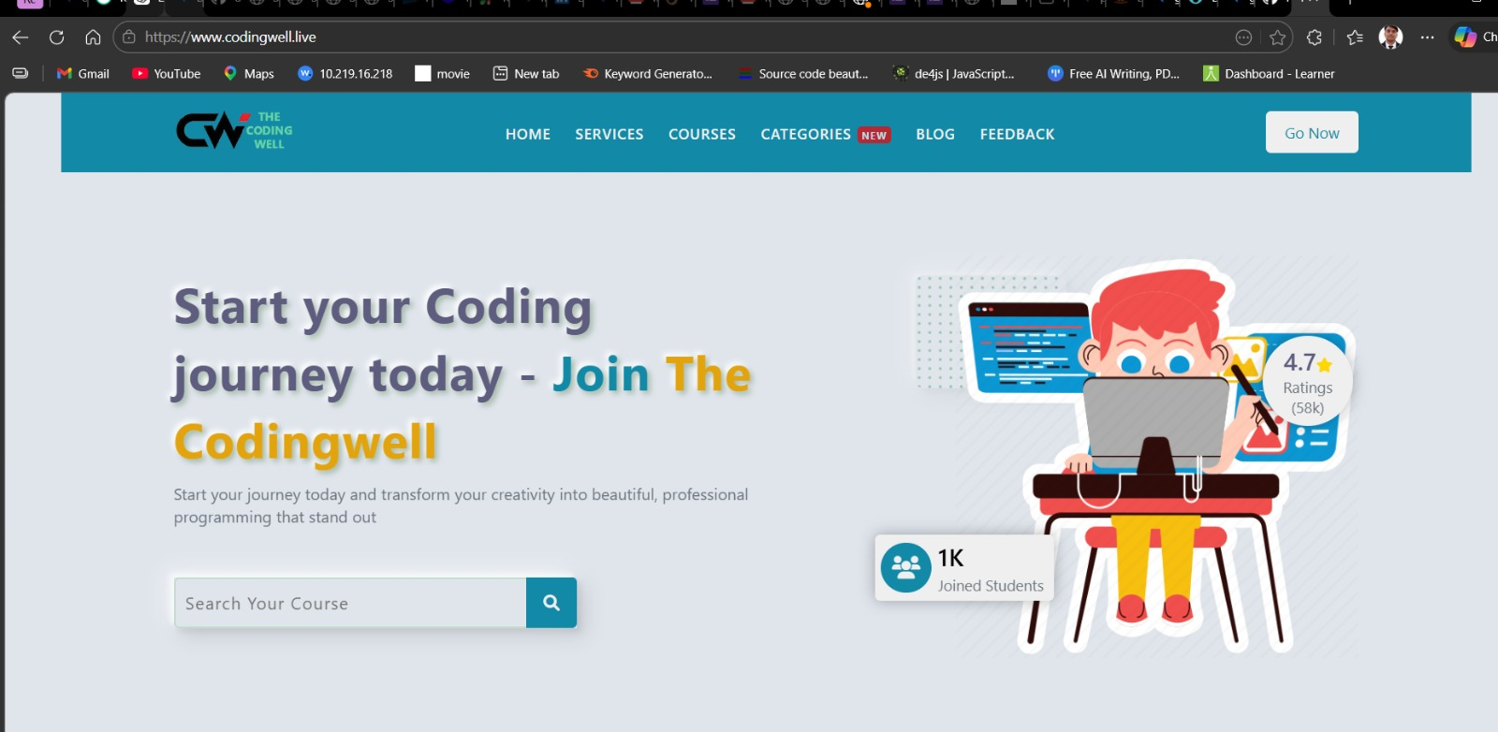
Final website UI showing homepage with navigation and content

3. Host the Website on a web server (FreeHosting.com, AwardSpace, etc).

Instead of traditional hosting, the website was deployed using GitHub Pages, which provides free static hosting.

Steps Performed:
- Created a GitHub repository
- Uploaded website files
- Enabled GitHub Pages in repository settings
- Selected deployment branch
- Generated live site URL

Outcome:
The website was successfully deployed and accessible via GitHub Pages.
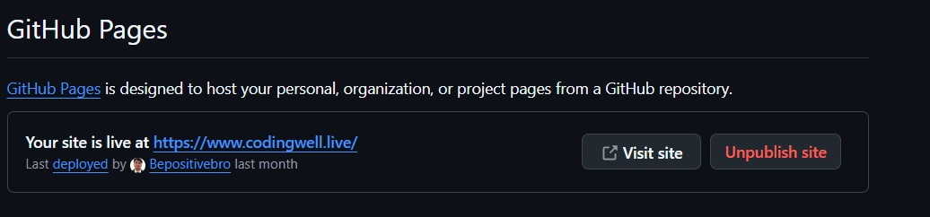
- GitHub Pages dashboard showing:
  - Live URL: https://www.codingwell.live
  - Deployment status

4. Configure DNS Records:
- Set up an A Record to point
your domain to the hosting server’s IP.
- Configure CNAME Record for
subdomains (if needed).
- Update Name Servers at the
registrar to connect the domain with your hosting provider.
DNS was configured to connect the custom domain with GitHub Pages hosting.
🔹 A Records Configuration:
The following A records were added to point the domain to GitHub servers:
- 185.199.108.153
- 185.199.109.153
- 185.199.110.153
- 185.199.111.153
These IP addresses belong to GitHub Pages infrastructure.
🔹 CNAME Configuration:
- Subdomain: www
- Points to: GitHub Pages domain
🔹 Nameserver Configuration:
- Default GoDaddy nameservers were used:
  - ns45.domaincontrol.com
Outcome:
DNS was successfully configured and verified.
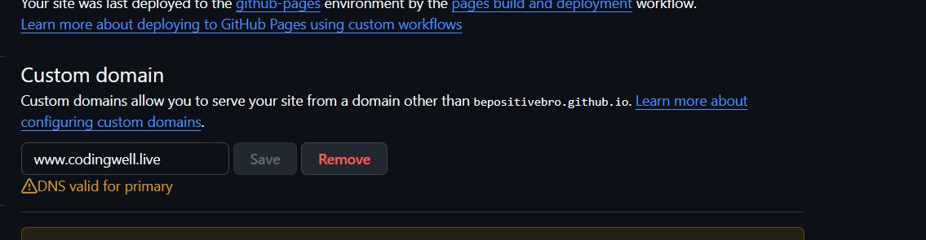

5. Verify Accessibility: Ensure your website is live and can be accessed through your purchased domain.
After DNS propagation, the website was tested.
Steps:
- Opened browser
- Entered: https://www.codingwell.live
Outcome:
The website loaded successfully and is publicly accessible worldwide.

Live website running in browser
Document Your Work: Provide screenshots and notes on:
- Domain purchase process.
- Hosting setup.
- DNS and name server configuration.
- Final website running on the
domain.

